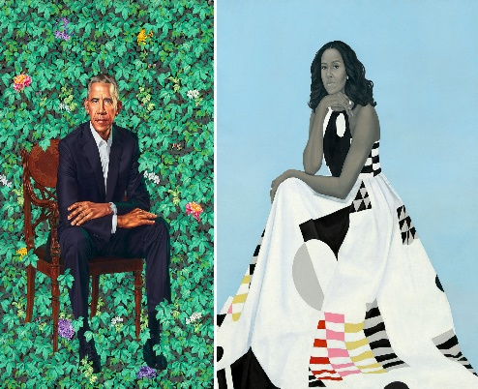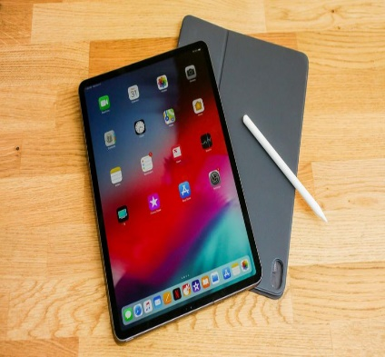
Music, Art, technology and Fashion of the 2010s
Time to check out the past ten years of pop culture! The decade started with Ke$ha’s hit song “Tik Tok” and (as you know) ended with the app Tik Tok making all kinds of songs and dances popular. In between that, we had the continued rise of artists such as Taylor Swift, Justin Bieber, and Ariana Grande; Broadway musicals like “Dear Evan Hansen” and “Hamilton”; social media developments like Instagram, Snapchat, and Vine; and artists like Banksy (whose true identity is unknown). As for technology- the advances made are mind blowing! Did you know the ipad wasn’t invented until 2010? Look how far we have come since then!
Options for possible assignments:
- Sketch your own album design that reflects the era. Try this with either pencil, crayon, pastel, watercolor, acrylic, etc. if you have the supplies. If you do not just sketch with a pencil for fun and relaxation.
- In Office 365 produce a Power point or Microsoft Word presentation on the musician of your choice from the 2010s (lots of possibilities- maybe look into how Tik Tok and Youtube have contributed to the rise of artists and songs!) Research where they grew up, their education, most popular songs, hobbies, where they are now, etc. Talk to your parents, grandparents, guardians, etc. about your findings…use the phone and call them (social distancing).
- In Office 365 produce a Power point or Microsoft Word presentation on artist of your choice from the 2010s (Banksy, Kehinde Wiley, and Amy Sherald) Research where they grew up, their education, most popular works, hobbies, where they are now, etc. Talk to your parents, grandparents, guardians, etc. about your findings…use the phone and call them (social distancing)
Note: If you are doing a Power Point or Word Presentation play around with the animations and transitions to keep yourself sharp. Try inserting a video or music. Use YouTube for help with any of these options or email me. LeRoy.Vincent@nbed.nb.ca
In your class files for week 4 look at the sketch book prompts file I’ve placed for you to practice…. if you have the time.

